Strategic Plan

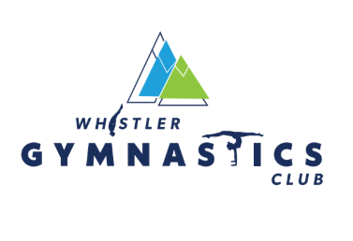

5 YEAR STRATEGIC PLAN (2026–2031)

WINNING ASPIRATION
To build the Sea to Sky’s most trusted and inclusive gymnastics community—fostering lifelong participation and strong athlete retention through exceptional coaching, meaningful career pathways for coaches, and clearly defined athlete development opportunities, while remaining affordable and financially sustainable.

STRATEGIC ARENAS

1. Location Strategy (Whistler + Pemberton)
One club, two locations with distinct roles and centralized management

2. School-Age Recreation (Ages 6–12)
Primary entry point and participation engine.

3. Development / Interclub Pathway
Core pipeline that builds athletes, culture, and future coaches.

4. Teen Retention & Gymnaestrada
Closes retention gap and supports gymnastics for all offerings

5. Competitive Programs (WAG + TG)
Performance pathway, brand legitimacy, and coaching career anchor.

6. Prime-Time Allocation (3–5:30 PM)
Our most scarce and strategic resource.

ORGANIZING PRINCIPLES
1. Athlete Engagement + Retention
We will prioritize keeping athletes longer and strengthen our pathways pipeline.

2. Coaching as a Career
We will professionalize and retain our coaches by providing:
- Benefits + RRSP matching
- Prioritize administrative efficiency
- Clear career pathways
- Professional Development opportunities
- Pursue avenues for staff housing
- Foster positive work environment

3. Clear Development Pathways
We will deliver a visible and structured journey:
Rec → Development / Gymnaestrada→ Competitive → Teen → Adult

4. Capacity Discipline
We will:
- Protect prime-time for core pathway programs
- Use off-peak for access, adult, and events
- Eliminate low-impact use of peak hours

5. One Club System
We will operate as a unified system across Whistler and Pemberton:
- Shared coaching model
- Shared pathways
- Leverage efficiencies with coordinated scheduling and programming
- Cohesive branding

CORE CAPABILITIES

1. Coaching System
- Recruitment pipeline (CIT → coach)
- Mentorship and certification pathways
- Career progression and retention model

2. Operational Support
- Clear job and role definitions
  - Coach
  - Coordinator
  - Manager
- Program Managers are autonomous and empowered to deliver their programs with administrative support from coordinators and Operations managers.

3. Capacity & Scheduling Discipline
- Strategic allocation of gym time
- Program prioritization by value (not tradition)

4. Financial Management + Governance
- Program-level profitability clarity
- Investment aligned to retention and pathways
- Long-term capital planning
- The Board will identify and manage financial risk by reviewing and approving the annual budget
- The Board will ensure accountability by performing regular variance reviews with the ED

5. Community & Parent Engagement
- Clear communication of pathways
- Strong parent-coach relationships
- Implement systems to encourage engagement between parent/athlete/coach on goal setting and metric evaluation throughout the year
- Host, and participate in, events that build community connection

KEY METRICS
- Athlete retention (year-over-year)
- Average athlete tenure (years in program)
- Coach retention and tenure
- Pathway conversion rates (Rec → Dev → Comp/Teen)
- Revenue per coaching hour
- Parent satisfaction
- Program enrollment / % full

PHASING (Business Plan)

Phase 1 (Years 1–2): Consolidation
- Stabilize staffing
- Optimize current programs
- Improve systems and scheduling

Phase 2 (Years 3–5): Focused Growth
- Expand high-retention programs
- Increase capacity strategically
- Deepen community integration

FINAL STRATEGIC ANCHOR
We win not by doing more, but by doing fewer things exceptionally well—aligned around retention, coaching excellence, a clear athlete progression pathway and a positive experience for athletes, staff and parents

Supporting Info
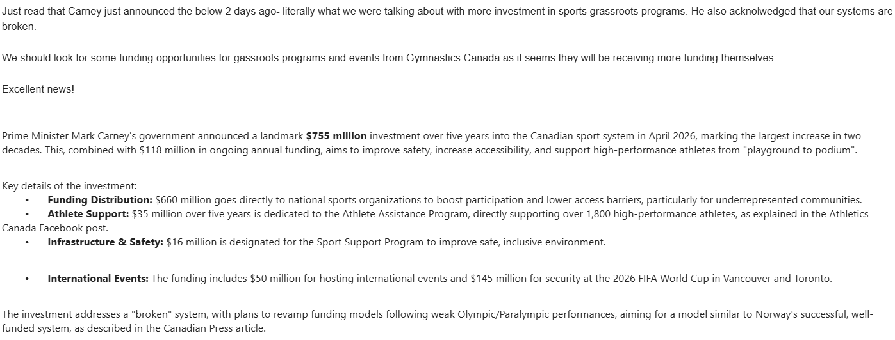

Business Plan Elaborations
- Criteria for Ninja program (Canjump approved moves)
- Program waitlist info
- Interclub that feeds a teen path (alternative high level recreation)
- Future admin position, uniforms/booking hotels
- Crossover with CSI/adaptive
- Pemberton ninja coaches
- Present to the regional district with specific request
- Gymnaestrada expansion / provincials
- Brand roll-out
- Scheduling - more hours of coaching in their strength
- Coaches camps
- Adult camps?
- ND programming. More trained coaches, 1-1 sensory grants
- Jeff Maynard - events support. 340 non-local participants
- Parallel funding streams

Capital and Equipment planning - Reserve maintenance

KPI scheduled reporting - (monthly, quarterly, annual metrics)

